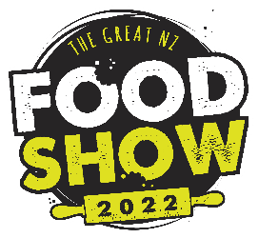
The Great NZ Food Show 2022
Hazard ID & Management Plan

Company Name:
Site Contact:
Site(s): Please use site number as per GNZFS Map
Commencement Date:
Site Specific Safety Plan completed by:

Monitoring and Performance
We are aware that GNZFS staff and volunteers will be monitoring onsite health and safety and may issue stop work or order contractors from site for breaches of health and safety. GNZFS staff may also request copies of health and safety documentation for review and contractors must keep copies of all documentation available onsite.

Signed: ………………………………………… Name: ……………………………………… Date: ………………………..……
Great NZ Food Show 2022 | Hazard ID & Management Plan
Exhibitor: Site No(s): Date:

Nature of Hazard | Possible Harm | Significant Hazard  Y/N | Control Measures | Controls Reviewed (Date) | Reviewed by (Initial)

